# MECH 325 – Team C2

1. Key

* key selected for 1.5 shaft.

2. Setscrew

* Factor of Safety of 5 assumed.
* Torque on lower shaft 52.68 lb-in
* Size #8 cup-point socket setscrew with length of 0.75 inches.

3. Retaining Rings

* Two 3AM1-38 retaining rings selected, suited to 1.5in shaft diameter.

4. Bearings

* Tapered roller bearings selected for shaft, Cone no. 3189, Cup no. 3120
* Reliability Factor, $R_{D}=0.95$
* Design Life in Hours, $L=40,000$
* Desired Life, $L_{D}= 288000000$ revs
* Rating Life, $L_{R}=90 * {10}^{6} revs$

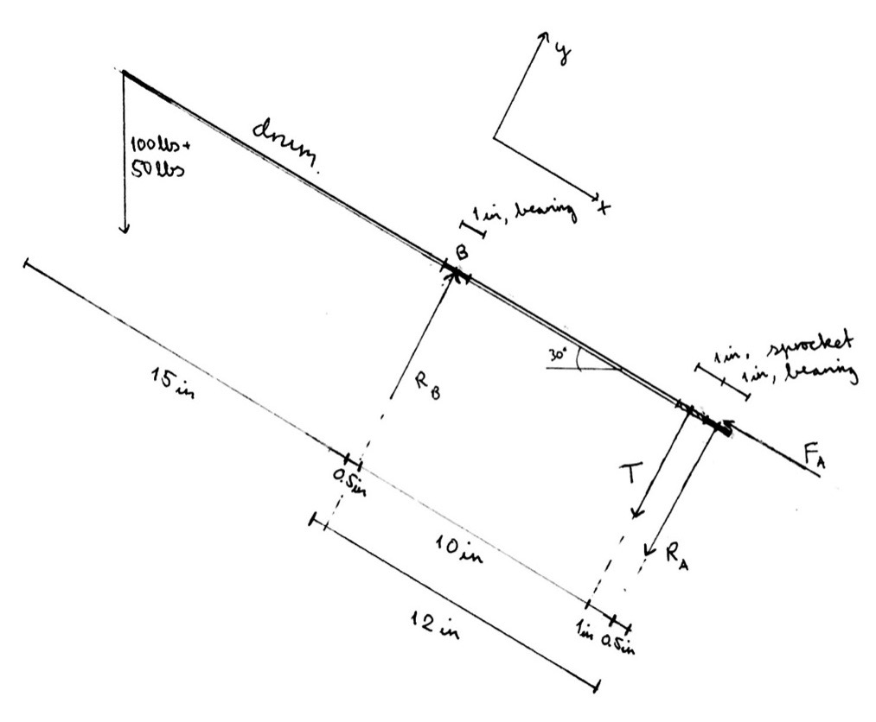

Assumptions and Methods

* Reliability > 0.95.
* Shock loading on drum due to early stages of Jelly-Bean handled by use of significant safety-factor.
* Shaft Material: G10450 cold-drawn steel with specific density of 7.87 $\frac{g}{{cm}^{3}}$ but we neglect the bending of the shaft.
* Ignore gravity loading of drum and motor mount mass for bolt calculations.
* Design costs for each component follows a model provided in the assignment.
* No calculations done for bearings on motor shaft.
* The mass of the shaft is negligible when calculating the force on the bearings.
* A negligible amount of power from the motor is not transferred to the shaft.
* The bolts are at a distance of 50cm from the middle of the motor mount base.
* The tension force can be conservatively modeled as cyclic to account for start-up acceleration vibrations, load irregularities, clumping of the beans.
* Assuming that $A_{D}$ is close enough to $A_{T}$ for the calculations needed to be performed.

5. Mounting Bolts

* 4 SAE Grade 2 1.5in steel bolts
* Infinite Life Safety Factor: 12.12
* Static Tension Load FOS: 1411.6

Cost Breakdown

Shaft Cost: $38.68

Machining Cost: $17.52

Keyway Cost: $15.00

Groove Cost: $20.01

Bearing Cost: $100

Bolt Cost: $4

Final Values

* Total Mass: 2.58 kg
* Total Cost: $195.23
* Performance Metric: 1.985 $×{10}^{-3}\frac{1}{kg \$}$